**IC-DTSDG-22**

**SIGN LANGUAGE DETECTION: A REVIEW**

Ms. Pallavi Maske (Author)

Student of B.E. (Information Technology)

Tulsiramji Gaikwad Pati College of Engineering And Technology

Nagpur, India

Ms. Sonali Patil (Author)

Student of B.E. (Information Technology)

Tulsiramji Gaikwad Pati College of Engineering And Technology

Nagpur, India

Ms. Achal Butke (Author)

Student of B.E. (Information Technology)

Tulsiramji Gaikwad Pati College of Engineering And Technology

Nagpur, India

***Abstract*- The Sign Language is a derived language for communication between deaf and dumb people. A Sign Language is one of the ways to communicate with deaf people. Every country has introduced its own sign language. The sign language developed in India is known as Indian Sign Language (ISL). The sign language is most reliable and significant way of communication between normal people and hard of hearing and speech impaired people without the need of interpreter.** **One should learn sign language to interact with them. In this paper, we present a literature of the latest advancements in the area of sign language (recognition). First, we review the techniques of gesture recognition and highlight some critical and important methods in recent developments. Next, we focus on the analysis and discussions about the challenges and any other possible solutions for the sign language recognition.** **We propose a method to create an Indian Sign Language dataset using a webcam and then using transfer learning, train a TensorFlow model to create a real-time Sign Language Recognition system.**

**Keywords: SLR (Sign Language Recognition), Gesture Recognition.**

# I. INTRODUCTION

Sign language (SL) is a visual-gestural language used by deaf and hard-hearing people for communication purposes. Sign language is the type of language that uses visual manual method to express something. SL is the means of communicating through hand signals, facial expressions and body language. It is means for the communication of hard of hearing community,

Mr. Chandrakant Prajapati (Author)

Student of B.E. (Information Technology)

Tulsiramji Gaikwad Pati College of Engineering And Technology

Nagpur, India

Miss. Priyanka Kanuje (Author)

Assistant Professor (Information Technology)

Tulsiramji Gaikwad Pati College of Engineering And Technology

Nagpur, India

but it can be also useful for other special communities too. Sign language are Full-fledged natural languages with their own grammar and lexicon. For mute and deaf community sign languages have been developed as useful means of communication and they form the core and backbone of local deaf cultures. Local people can form their own gestures and actions to convey the message locally. It is way through which the deaf and dump can easily communicate to the external world. Gestures can be determined by physical motion of different body parts such as fingers, arms, hands, head, neck, eyes, etc. Gestures are very essential component as it provides all the meaningful information.

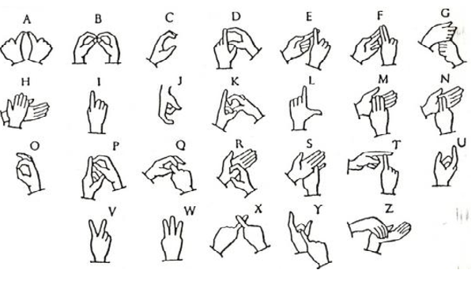

Figure 1. Representation of ISL Alphabets(A-Z)

People with disabilities including Autism, Apraxia of speech, Cerebral Palsy and Down Syndrome like the SLR is beneficial for communication. During the conversion between the deaf and normal person, the deaf people can easily communicate through with the help of their sign language and the normal people can use the sign language predictor to understand what the other person is trying to say. The conversation between the deaf and normal people become difficult. Most of the people don’t understand the sign language as it is not a very common way of conversing. Through sign language recognition one can easily understand what the other wants to convey. The purpose of sign language detection system is to provide an efficient and accurate way to convert language into text messages. The system has a huge future scope as it makes communication more efficient and easier. This promotes cultural awareness, literacy, and other intellectual benefits

# II. PURPOSE

Sign languages are defined as an organized collection of hand gestures having specific meanings which are employed from the hearing-Impaired people to communicate in everyday life. Being visual languages, they use the movements of hands, face, and body as communication mediums. The percentage of population knowing any of them is low which makes it difficult for the specially-abled people to communicate freely with everyone. SLR provides a means to communicate in sign language without knowing it. It recognizes a gesture and translates it into a commonly spoken language like English.

# III. GESTURE RECOGNITION APPROACHES

Gestureis referred as any non-verbal communication i.e.;

Whose aim to communicate with specific message. Gesture recognition is a computing process that attempts to recognize and interpret human gestures through the use of mathematical algorithms. Gesture recognition is not limited to just human hand gestures, but rather can be used to recognize everything from head nods to different walking gaits. Gestures allows one to express their feelings, thoughts, emotions, etc. Gesture recognition is a process of movement of body parts specially through hands, limbs, head to convey one's message. Gesture recognition computer processes are designed to enhance human-computer interaction, and can occur in multiple ways, such as through the use of touch screens, a camera, or peripheral devices. The main purpose of the gestures is to understand the sign language which will directly help in SLR (Sign Language Recognition). Gesture recognition is a type of perceptual computing user interface in which the computers capture the gesture and convert the human gestures into commands. The real meaning of gesture recognition is the ability of a system to understand the gestures and execute the commands accordingly. SLR approaches are categorized based on the gadgets used to recognize the SL. The hand gesture recognition is performed using following techniques: (i) Vison Based and (ii)Data glove approach (instrumented).

1. **Vision Based Approach (VBA)**

Just like the name suggests, this vision-based approach for SLR uses image or video as an input. If the input is a video, successive frames are taken into consideration. Video based method are widely deployed for Sign Language Recognition. In these methods, sign gestures are captured by a fixed camera in front of signers. The extracted images convey posture, location and motion features of the fingers, palms and face. Camera is in acting a main input device which is used to capture the images. After that the images that will used for further processing. In this approach mainly, gloves are not used. VBA is comparatively easier and has lower computational cost.

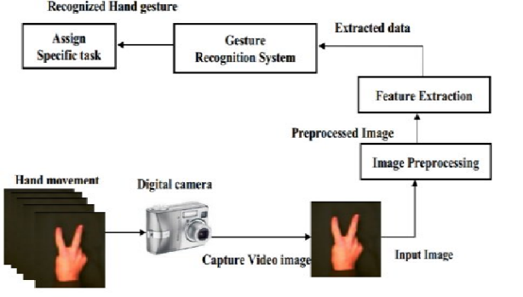

Figure 2. VBA

In order to create the database for gesture system, the gestures should be selected with their relevant meaning, and each gesture may contain multi samples for increasing the accuracy of the system. To recognize the corresponding sign image preprocessing and signal preprocessing if performed. The capture image is transferred to the preprocessor and then the feature vector of the image is compared with the already stored data set. Few probabilities are determined during this operation and using the final probability, the sign is divided into its corresponding class. VBA initiates human computer interface VBA approach for SLR is shown in Fig 2.

1. **Data Glove Approach (DGA)**

For capturing the pose of the hands and its motion data gloves are used. The gloves are connected to both hands. Since the hundreds of sensors are attached to the gloves, the position of the hand placement and orientation are calculated accurately. These methods employ mechanical or optical sensors attached to a glove that transforms finger flexions into electrical signals to determine the hand posture. As depicted in Figure 1, using this method the data is collected by one or more data-glove instruments, which have different measures for the joint angles of the hand and Degree of Freedom (DOF) that contain data position and orientation of the hand used for tracking the hand. The fast reaction speed is the main advantage of this method This approach is highly accurate. It is not affordable by the common deaf people as it consists of high-cost sensors DGA approach for SLR is shown in Fig 3.

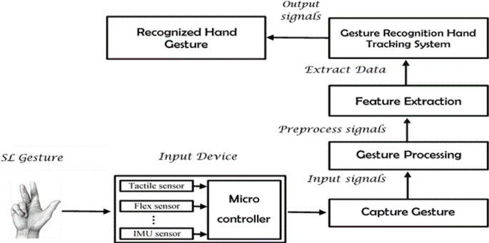

Figure 3. DGA

# IV. Related Work

1. There are several methods of implementation and systems existing at present. Every one of them is diverse in a few or different capacities. Some have distinctive calculation and methods utilized for perceiving the hand motion. Hand gesture acknowledgment framework is considered as a path for increasingly natural and capable human-computer interaction tool.
2. Already existing system is present for the recognition of ISL using ANN (Artificial Neural Network and SVM (Support Vector Machine) classifiers [1] Using these too techniques they have developed the recognition system The gestures were recognized using various feature extraction techniques like shape descriptors, SIFT and HOG individually along with SVM classifier and all they have combined all these features and found that f combined approach provides an accuracy of 57% Combination of 100 and ANN provides the accuracy a high as 99%.
3. The proposed scheme translates the ISL numerals and alphabets into English. Combinational algorithm is adapted which includes Canny edge detection. YCbCr model for segmentation threshold etc. for tracking hand movements. An accuracy of 97.5% is achieved. The complete system was developed in MATLAB and Graphical User Interface (GUI).

# v. PROPOSED SYSTEM

A real-time sign language detection system is being developed for Indian Sign Language. For data acquisition, images are captured by webcam using Python and OpenCV. OpenCV provides functions which are primarily aimed at the real-time computer vision. It accelerates the use of machine perception in commercial products and provides a common infrastructure for the computer vision-based applications.

In this proposed project we will be building a recognition model.

* For this we will be collecting the images for deep learning using webcam and OpenCV.
* We will label the images for the sign language detection using Labelling.
* Setting up TensorFlow Object Detection Pipeline Configuration.
* Creating the deep learning model using transfer learning.
* Detecting sign language in the real time using OpenCV.

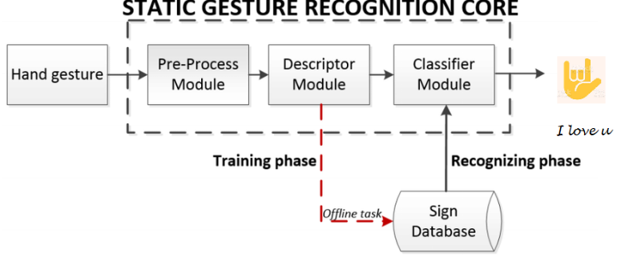

# vI . CONCLUSION

This paper presents a survey on different hand gesture Le sign language. The main aim of this recognition system is to enhance the human-machine interaction. The drawback is that not everyone possesses the knowledge of sign languages which limits communication. This limitation can be overcome by the use of automated Sign Language Recognition systems which will be able to easily translate the sign language gestures into commonly spoken language. In this paper, it has been done by TensorFlow object detection API. The system has been trained on the Indian Sign Language alphabet dataset. The system detects sign language in real-time. For data acquisition, images have been captured by a webcam using Python and OpenCV which makes the cost cheaper. In the recent years there has been development in the area of static hand gesture. Only few works have been reported related to dynamic hand gesture recognition. Most of the system are dependent on signer. In most widely used system the facial expressions are not included. The key challenge is to develop a system that will recognize both facial and hand gestures together.

# vII . References

1. J. Ekbote and M. Joshi. "Indian sign language recognition using ANN and SVM classifiers", 2017 IEEE International Conference on Innovations in Information, Embedded and Communication Systems (ICIIECS) 2017
2. P.C. Badhe and V. Kulkarni, "Indian sign language translator using gesture recognition algorithm," 2015 IEEE International Conference on Computer Graphics. Vision and Information Security (CGVIS), Bhubaneswar, 2015, pp. 195-200
3. Nimisha K P and A. Jacob. "A Brief Review of the Recent Trends in Sign Language Recognition" 2020, IEEE International Conference on Communication and Signal Processing (ICCSP), 978-1-7281-4988-2/20 Reaju P Band Kausik, "Hand Gesture Recognition using Deep Root Nodal Architecture, 2019 IEEE 978-1-7281-0089-0/19
4. T. Daphne, M. Kevin," Implementing Gesture Recognition in a Sign Language Learning Application. IEEE 2020 Iris Signals and Systems Conference (ISSC).
5. Nimisha K P and A Jacob, "A Brief Review of the Recent M. Al-Had G. Muhammad, W. Abdul Trends in Sign Language Recognition" IEEE International Conference on Communication and Signal Processing (ICCSP), 978-1-7281-4988-2/20
6. Renju P B and Kausik. "Hand Gesture Recognition using Deep Root Nodal Architecture", 2019 IEEE 978-1-7281-0089-0/19
7. S. Nikam and A. G. Ambekar. "Sign Language Recognition using Image Based Hand Gesture Recognition Techniques" 2016 Online International Conference on Green Engineering and Technologies (IC-GET)
8. M. Al-Had G. Muhammad, W. Abdul M Alan T. S. Abayes I Make, M. A. Makhoshe "Deep Lang-Based Approach for Sug Language Gestare Rog with Efficient Hund Get Reperemation 2020 IEEE ACCET
9. [MJN K. Bhayit. Viss Y Rathe GN. "Indian Sign Lange Gen Recognition ng Image Png and Deep Learning 2019, IEEE 978-1- 7281-3457-29 K Bhop Vis Y Ratna G N. "Indian Sign Language Gesture Recognition at Image Pincewing and Demp Learning 2019 IEEE 978-1-7283-3857-29
10. A. S. Nikam and A. G. Ambekar. "Sign Language Recognition using Image Based Hand Gesture Recognition Techniques" 2016 Online International Conference on Green Engineering and Technologies (IC-GET)